
WEB Quest
Items in blue offer some information and notes and items underlined are links to help you get answers. Questions are numbered and may be highlighted = answer where you see this Answer:

Applied Information Technology

Web Quest Introduction to the Internet
Instructions:
This document is a web quest and information worksheet, (some information has been provided but you must find more for the web quest (end of document)). If it is not included in this document a web link will be available to help you! But you should create more links to find information.

Copy the web quest sheet (at the end of this document, complete it and paste it into your marking folder) before the end of next week.

Save this document to a folder called AIT Revision or print it out and put it into your file.

WEB QUEST SHEET
Your Name:

1. Who started the Internet?
http://www.walthowe.com/navnet/history.html

Answer:

2. Explain the original purpose and development of the Internet
Answer:

3. Identify three types of users of the Internet
Answer:

4. Identify and define features of the Internet
Answer:

5. Explain the services provided by the Internet their advantages and disadvantages
Answer:

6. Identify different types of networks. LAN, WAN, Internet.
Answer:

7. Who would use a client-server network?
http://compnetworking.about.com/cs/basicnetworking/f/whatsnetworking.htm
Answer:

8. Who would use peer-to-peer networks?
http://compnetworking.about.com/od/basicnetworkingfaqs/a/peer-to-peer.htm
Answer:

9. Access the Internet and Locate the following Information on the Internet
Plot Summary for “Enemy of the State”
Answer:

10. Use a variety of search methods to locate specified information on the Internet

Images from the film “Enemy of the State” including two shots from the movie
(3 images to find)
Answers:

11. List 3 Advantages for using the Internet at a college?
Answer:

Answer:

Answer:

12. List 3 Disadvantages of downloading items from the internet?
Answer:

Answer:

Answer:

13. What is Phishing and Pharming
Answer:

http://www.crime-research.org/news/09.11.2005/1614/

14. What is Digital Convergence
Answer:

http://www.globrocks.com/globrockssitearticles/digitalconvergence.html

15. Network topology Show three types of network topology
(Images will suffice)
http://en.wikipedia.org/wiki/Computer_network#Connection_method

Answer:

Answer:

Answer:

16. Convert the following decimal numbers to their binary equivalent.
http://computer.howstuffworks.com/bytes.htm

25, 10, 181, 327

Hint
You will need to set up a table similar to the one below to help you in answering the questions. This may need to be expanded.

64 | 32 | 16 | 8 | 4 | 2 | 1

17. What are the rules for preventing Cyber Bullying or Predator Danger on the Internet?
http://workingmothers.suite101.com/article.cfm/cyberbullying_and_online_predators
http://www.cybersmart.gov.au/

END OF WEB QUEST

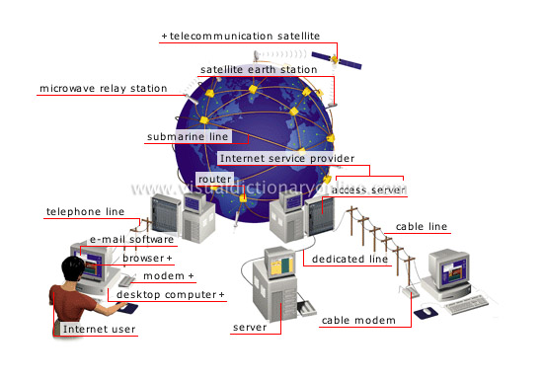
Worksheet - The Internet and Networking Bits

The Internet has opened the business world to an explosion of potential customers by enabling access by tens of millions of people across all continents. Businesses can use the Internet to advertise and publish information, buy and sell goods and services, access information from competitors prices to travel timetables to the latest business news to a government documents, send and receive electronic mail with colleagues and clients, link computer networks across national and international borders, transfer files from one place to another and conduct banking services such as transferring funds, paying bills and checking account balances.

Development of the Internet

The Internet began in the United States back in the early 1960’s. The Department of Defense’s Advanced Research Association (ARPA) developed a small network to allow the sharing of information between military personnel and scientific researchers.
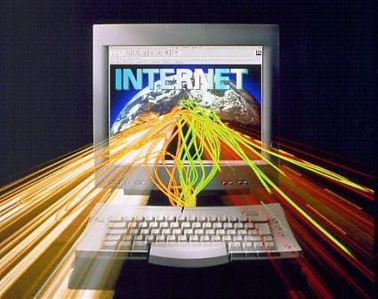

This was called the ARPANET. ARPANET was enhanced to withstand a military attack from an enemy by maintaining communication even if one or more of the computers became unavailable. The system was based on a standard set of rules called protocol that defined how computers would communicate, much the same as people have implicit rules for speaking to one another.

The ARPANET grew to include academic institutions throughout the US and a few overseas. The military became concerned that the increased use of the network may jeopardise national security and decided to sever its links with the ARPANET.

This cleared the way for academics to expand their use of the Internet and business interests to initiate commercial use of the Internet.

The internet has grown to over 60 million sites.

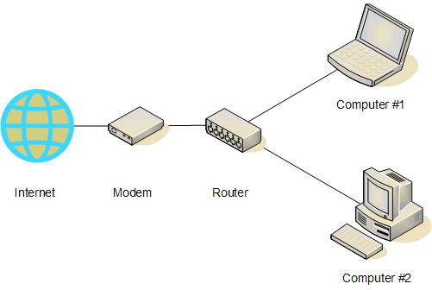
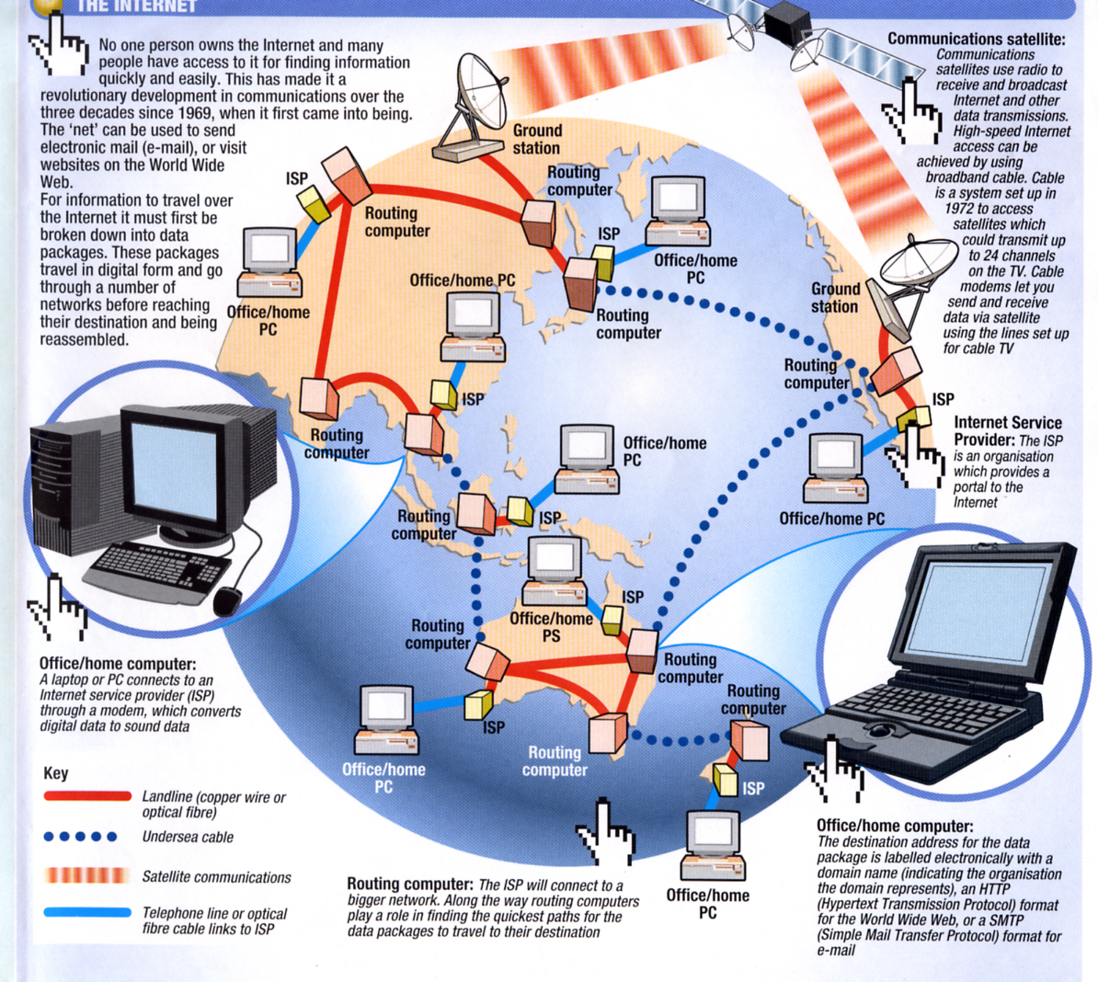
How do networks communicate?
The methods used by computers and networks to communicate with each other is through network protocols.

A network protocol is a set of rules for communicating between computers. Protocols govern format, timing, sequencing, and error control. Without these rules, the computer cannot make sense of the stream of incoming bits.

What is a protocol, really? It is software that resides either in a computer's memory or in the memory of a transmission device, like a network interface card. When data is ready for transmission, this software is executed. The software prepares data for transmission and sets the transmission in motion. At the receiving end, the software takes the data off the wire and prepares it for the computer by taking off all the information added by the transmitting end

There are different types of protocols used by different companies. TCP, TCP/IP, IPX/SPX, NetBEUI and NetBIOS. These protocols are used depending on which organisation or company owns it. The all facilitate the same thing in that they allow the communication of data on their network. The OSI model standards have helped with the different protocols and enable them all to be able to communicate effectively. If we take for example the internet, we can see that there are a lot of different variety of computers and network all connected together in a harmonious and efficient way.

How is information sent? Bits & Bytes
In this worksheet, we will discuss bits and bytes so that you have a complete understanding.
If you have used a computer for more than five minutes, then you have heard the words bits and bytes. Both RAM and hard disk capacities are measured in bytes, as are file sizes when you examine them in a file viewer.
You might hear an advertisement that says, "This computer has a 32-bit Pentium processor with 64 megabytes of RAM and 2.1 gigabytes of hard disk space
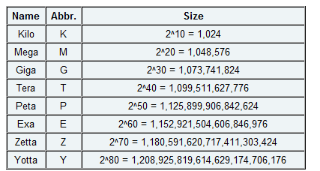

Decimal Numbers
The easiest way to understand bits is to compare them to something you know: digits. A digit is a single place that can hold numerical values between 0 and 9. Digits are normally combined together in groups to create larger numbers. For example, 6,357 has four digits. It is understood that in the number 6,357, the 7 is filling the "1s place," while the 5 is filling the 10s place, the 3 is filling the 100s place and the 6 is filling the 1,000s place. So you could express things this way if you wanted to be explicit:
(6 * 1000) + (3 * 100) + (5 * 10) + (7 * 1) = 6000 + 300 + 50 + 7 = 6357
Another way to express it would be to use powers of 10. Assuming that we are going to represent the concept of "raised to the power of" with the "^" symbol (so "10 squared" is written as "10^2"), another way to express it is like this:
(6 * 10^3) + (3 * 10^2) + (5 * 10^1) + (7 * 10^0) = 6000 + 300 + 50 + 7 = 6357

Computers - Use the Base-2 System and the 8-bit Byte
The reason computers use the base-2 system is because it makes it a lot easier to implement them with current electronic technology. You could wire up and build computers that operate in base-10, but they would be fiendishly expensive right now. On the other hand, base-2 computers are relatively cheap.
So computers use binary numbers, and therefore use binary digits in place of decimal digits. The word bit is a shortening of the words "Binary digIT." Whereas decimal digits have 10 possible values ranging from 0 to 9, bits have only two possible values: 0 and 1. Therefore, a binary number is composed of only 0s and 1s, like this: 1011. How do you figure out what the value of the binary number 1011 is? You do it in the same way we did it above for 6357, but you use a base of 2 instead of a base of 10. So:

(1 * 2^3) + (0 * 2^2) + (1 * 2^1) + (1 * 2^0) = 8 + 0 + 2 + 1 = 11
You can see that in binary numbers, each bit holds the value of increasing powers of 2. That makes counting in binary pretty easy. Starting at zero and going through 20, counting in decimal and binary looks like this:
0 = 0
1 = 1
2 = 10
3 = 11
4 = 100
5 = 101
6 = 110
7 = 111
8 = 1000
9 = 1001
10 = 1010
11 = 1011
12 = 1100
13 = 1101
14 = 1110
15 = 1111
16 = 10000
17 = 10001
18 = 10010
19 = 10011
20 = 10100
When you look at this sequence, 0 and 1 are the same for decimal and binary number systems. At the number 2, you see carrying first take place in the binary system. If a bit is 1, and you add 1 to it, the bit becomes 0 and the next bit becomes 1. In the transition from 15 to 16 this effect rolls over through 4 bits, turning 1111 into 10000.
Bits are rarely seen alone in computers. They are almost always bundled together into 8-bit collections, and these collections are called bytes. Why are there 8 bits in a byte? A similar question is, "Why are there 12 eggs in a dozen?" The 8-bit byte is something that people settled on through trial and error over the past 50 years.
With 8 bits in a byte, you can represent 256 values ranging from 0 to 255, as shown here:
0 = 00000000
1 = 00000001
2 = 00000010
...
254 = 11111110
255 = 11111111
In the article How CDs Work, you learn that a CD uses 2 bytes, or 16 bits, per sample. That gives each sample a range from 0 to 65,535, like this:
0 = 0000000000000000
1 = 0000000000000001
2 = 0000000000000010
...
65534 = 1111111111111110
65535 = 1111111111111111

A computer system is unable to understand words, numbers, images or video, it needs to break these down into smaller units. When we look at file handling in more detail, we see that data is represented by a binary system. Each piece of data is represented as either a zero or a one (off or on) binary digit (bit). A bit is the smallest unit a computer can process. A group of eight bits is called a byte, and typically represents a character.

Size | Abbreviation | Number of Bytes
Kilobyte | KB or Kb or kb | 1 024
Megabyte | MB or M | 1 048 576
Gigabyte | GB or G | 1 073 741 824
Terabyte |  | 1 099 511 627 776
Petabyte |  | 1 125 899 906 842 624
Exabyte |  | 1 152 921 504 606 846 976

Comparison of Various Sizes of Memory

So how do we get these values? It seems odd that a kilobyte is 1024 bytes where a kilogram is 1000 grams. Why the extra 24 bytes? The answer is because in computing we use the base-2 numbering system, where as in the decimal system we are using a base-10.

Base-2 Numbering System
In a base-2 numbering system, numbers are composed of only 0s and 1s, like this: 1101. How do you figure out what the value of the binary number 1101 is?
(1 * 2³) + (1 * 2²) + (0 * 2¹) + (1 * 2⁰)
= 8 + 4 + 0 + 1
= 13

So how do we get 1024 bytes, not 1000 bytes? Let us look at the following equation. In a base-2 numbering system this is the closest that you can get to 1000. When we are referring to gigabytes of space these 24 bytes becomes quite large (over 73MB in fact).

(1 * 2⁹) + (1 * 2⁸) + (1 * 2⁷) + (1 * 2⁶) + (1 * 2⁵) + (1 * 2⁴) + (1 * 2³) + (1 * 2²) + (1 * 2¹) + (1 * 2⁰)

= 512 + 256 + 128 + 64 + 32 + 16 + 8 + 4 + 2 + 1
= 1024

Binary math works just like decimal math, except that the value of each bit can be only 0 or 1. To get a feel for binary math, let's start with decimal addition and see how it works. Assume that we want to add 452 and 751:

452
+ 751
---
1203
To add these two numbers together, you start at the right: 2 + 1 = 3. No problem. Next, 5 + 5 = 10, so you save the zero and carry the 1 over to the next place. Next, 4 + 7 + 1 (because of the carry) = 12, so you save the 2 and carry the 1. Finally, 0 + 0 + 1 = 1. So the answer is 1203.
Binary addition works exactly the same way:
010
+ 111
---
1001
Starting at the right, 0 + 1 = 1 for the first digit. No carrying there. You've got 1 + 1 = 10 for the second digit, so save the 0 and carry the 1. For the third digit, 0 + 1 + 1 = 10, so save the zero and carry the 1. For the last digit, 0 + 0 + 1 = 1. So the answer is 1001. If you translate everything over to decimal you can see it is correct: 2 + 7 = 9.
To sum up, here's what we've learned about bits and bytes:
- Bits are binary digits. A bit can hold the value 0 or 1.
- Bytes are made up of 8 bits each.
- Binary math works just like decimal math, but each bit can have a value of only 0 or 1.

Bit and byte arithmetic
Q. You can download a file over the network at a speed of 56 Kb per second. The file is 2 MB long. How many seconds will it take for the file to download?
56 Kb per second is 56,000 bits.
It takes 8 bits to represent a byte of information. 56,000 (divided by 8) bits per second = 7,000 bytes per second.
2 MB is 2 million bytes. Divide 2,000,000 by 7,000 to get the number of seconds.
Answer: 285.7 seconds.
Q. How many bits are in a message that is 20 KB in size?
20 KB is 20,000 bytes. One byte contains 8 bits of information. 20,000 x 8 = 160,000.
Answer: 160,000 bits.

Network topology
Computer networks may be classified according to the network topology upon which the network is based, such as bus network, star network, ring network, mesh network, star-bus network, tree or hierarchical topology network. Network topology is the coordination by which devices in the network are arranged in their logical relations to one another, independent of physical arrangement. Even if networked computers are physically placed in a linear arrangement and are connected to a hub, the network has a star topology, rather than a bus topology. In this regard the visual and operational characteristics of a network are distinct. Networks may be classified based on the method of data used to convey the data, these include digital and analog networks.

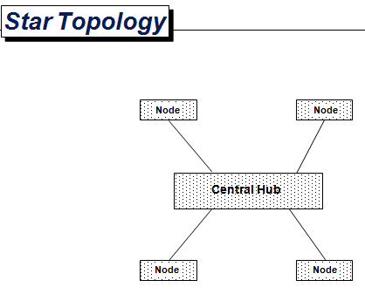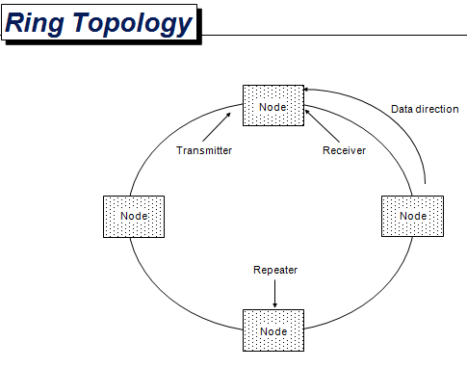
Internal and External Networks

Networks are formed when computers are connected to each other in order to communicate, share resources and transfer information. In your workplace, if your computer is linked to other computers in the same area, the network is known as a local area network (LAN)
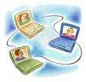
(Possibly peer-to-peer).

If your computer is linked to an office in Melbourne or Sydney or Bendigo, then the network is probably a wide area network WAN). (Possibly client-server).

The Internet is a worldwide collection of many thousands of computer networks, it is in fact a network of networks that can relay information within seconds to almost anywhere around the world.

Today, no organisation or body owns the Internet but it is regulated and controlled by some responsible authority in each country, normally a communications company. Until 1995 Australia’s part of the Internet was regulated by the Australian Academics Research Network (AARNET) which was funded by universities and other academic institutions. These days Telstra is responsible for maintaining the required infrastructure and to coordinate all access to the Internet across Australia.

As we mentioned before, protocol is a set of rules that allows different types of computers to interconnect and share information. The network protocol used on the ARPANET, and still used today, is called Transmission Control Protocol/Internet Protocol (TCP/IP). TCP determines how computers communicate with each other. IP regulates the naming and addressing of those computers. Another important protocol used on the Internet is Serial Line Internet Protocol/Point to Point Protocol (SLIP/PPP). SLIP and PPP are the protocols used by computers to connect to an Internet Service Provider (ISP) via a modem. When you run SLIP or PPP on your home computer you are assigned an IP address and can be identified on the Internet for the period of time you are connected.

Who Uses the Internet
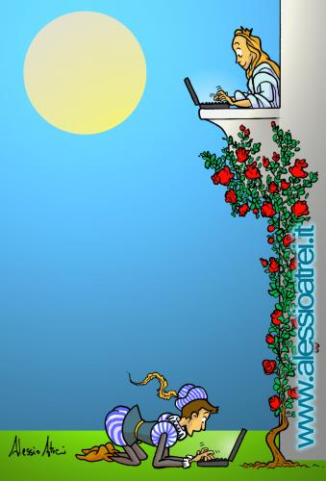

We know that scientific researchers and university academics were active in the early beginnings of the Internet and their involvement continues today. They use the Internet for distributing, searching and retrieving files and articles, corresponding via email and providing educational sites involving audio, visual and interactive capabilities. Business organisations use internal email extensively on their LANs and WANs but also access the Internet to communicate nationwide or worldwide. They promote business ideas and concepts, advertise and trade goods and services as well as keeping an eye on the competition. Governments distribute documents such as recent policy development, legislation and parliamentary transcripts. Government departments, at all levels from local to national, use email extensively and provide information on current issues for public benefit such as how to deal with the Y2K bug. On-line education is a growing area touching students from primary to tertiary levels. Students in school on one side of the world can chat with students in another part of the world, get help for their next assignment from an electronic library or access a virtual expert on a range of subjects from mathematics to medicine. Universities use the Internet to distribute educational material, course information, conduct tests and publish end of semester results. On-line and interactive learning enables people living in remote locations to have the same educational opportunities as people elsewhere. The Internet does not restrict anyone from using its facilities and people without a computer at home can log on from libraries, schools, and work or at cybercafes. People can play interactive games, read on-line books, go shopping, pay bills, look at the stock market fluctuations, check out the sports results, read today’s newspaper or browse from site to site otherwise known as ‘surfing the net’.

Internet Users
Society’s appetite for the information age is increasing rapidly. Just think of our daily activities compared to those of our parents when they were young! ATM’s, faxes, email, videos and mobile phones weren’t even thought of 30 years ago. So where are we heading? In the US more than 60% of the population pay for home entertainment through cable TV. In the future the home may have a complete home communication system that will have access to interactive TV, a database of video recordings, educational institutions, cyber shopping malls, on-line banking and other information services linked by a fast, high capacity, reliable and affordable communication line. This future scenario is all part of the Information Superhighway predicted to change the way we live. Look at the recent strength in the share price of communication companies such as Telstra, Optus, and OneTell.
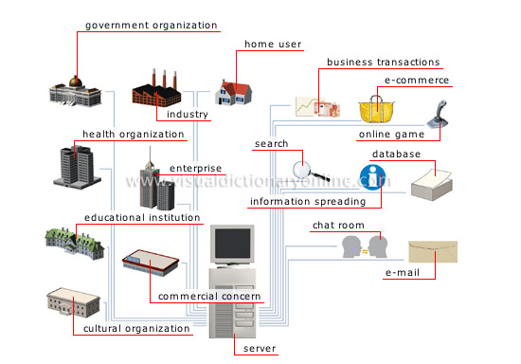

It is an indication of the growing market in communications and if the US is any indication PAY-TV will be the next growth area. While in Australia, PAY-TV is perceived as a way for companies to gain a market foothold for when the Information Superhighway becomes a reality.

Hardware and Software Requirements

When accessing the Internet, a newer computer will provide greater speed and memory than older computers. This will make the experience more fun as it can be quite frustrating when waiting lengthy periods for information to download. That’s why some people call the Internet the ‘World Wide Wait’. If you have a computer that’s more than a few years old, don’t throw it out just yet, it will still do the job and may suit your initial requirements.

The basic requirements for access to the Internet are

- A computer
- A modem
- A telephone line connection
- Communication software
- An Internet account with an Internet Service Provide (ISP)
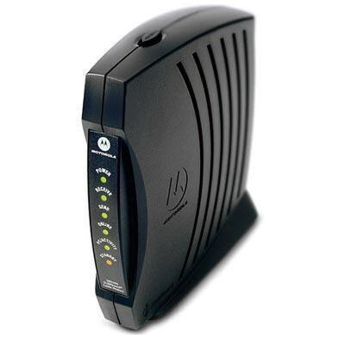
A modem is a piece of hardware which converts digital signals from the computer to analogue signals that can be transmitted across the telephone line (known as modulation) and converts the analogue signals received from the telephone line back to digital signals for the computer to use (known as demodulation).

A normal telephone line connection used at home or work is all that is necessary connection to the modem. Some households install a another line for accessing the Internet so that phone calls can still be made and received on the original line.

The communication software required for connection to the Internet is provided free by the ISP in the form of a CD-ROM or floppy disk. The installation process sets up the configuration details the computer needs for connection to each particular ISP. Most ISP’s also provide extensive technical support if you ever run into trouble.

You will also need to open an Internet account with an ISP. An ISP is an organisation or individual that provides a permanent connection to the Internet through a host computer and then sells access to the public. Every time you connect to the Internet you have to pay for the telephone call to the ISP’s host computer, so make sure that you use an ISP that requires a local call not an STD call.

Internet Features

The main Internet services available to users are
- World Wide Web (WWW)
- e-mail
- Mailing lists
- Usernet use
- Internet Relay Chart (IRC)
- File transfer protocol (FTP)
- Electronic commerce.

World Wide Web

The WWW requires a software application called a browser, such as Netscape Navigator, Firefox or Internet Explorer, to connect to the web. This allows web sites to be accessed and information downloaded to your computer.
E-Mail

Email is extensively used and a great innovation for anyone with access to a computer. It allows short notes, letters and large documents to be electronically transmitted anywhere in the world within a matter of minutes. Email address comprises of a userID, an @ symbol and a domain name. The user id is the users identification. The @ symbol is pronounced “at” and the domain name identifies the ISP host computer amongst all the computers on the Internet. An example email address is microstar@bigpond.com.au


Mailing Lists

Mailing Lists are an extension of email. An originator (list owner) advertises for people to share information and opinion on a particular topic and provides and email address to contact if interested in subscribing. The originator complies the list of participants email addresses and sets up the mailing list. When information is posted to the mailing list email address all subscribers receive the information.


Usernet News

Usernet News operates as a collection of bulletin boards or noticeboards known as newsgroups. Unlike mailing lists, no one person is responsible for developing or maintaining these groups but anyone can start a newsgroup. Each newsgroup covers one particular topic and can be used by any number of people be emailing to the newsgroup and sharing opinions on the topic an replying to other messages. Application software such as Internet news is required to access these newsgroups.



Internet Relay Chat

Internet Relay Chat (IRC) is the party line of the internet enabling many people to electronically chat at one time. Messages sent by participants are displayed on the screen allowing all other participants to reply. There is a certain etiquette to these chat groups and participants are expected to use the greetings “hello” and “goodbye” appropriately.
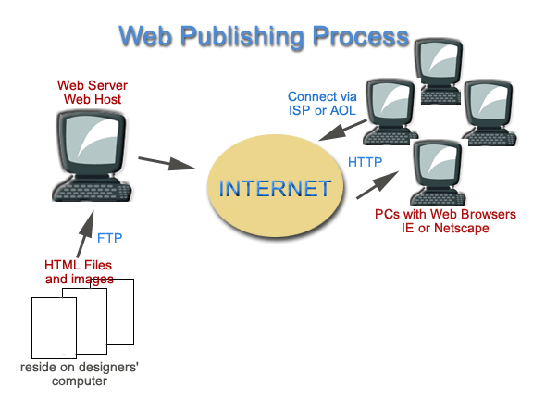
File Transfer Protocol

File Transfer Protocol (FTP) enables a user to access required sites and to copy files from one computer to another. Used in publishing your web sites.

Electronic Commerce

Electronic Commerce is an area creating huge interest amongst the business world. It is one of the fastest growing uses of the internet as traders advertise and sell their products and services through the web. Customers browse cybershops and cybermalls, then place orders on electronic order forms and pay by credit card.
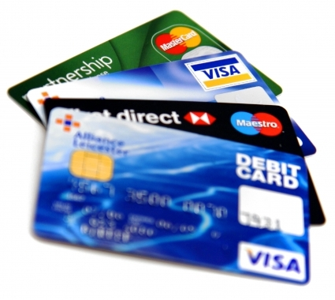
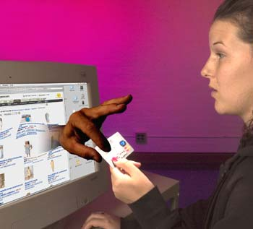

Advantages and Disadvantages of the Internet

There are many advantages and disadvantages of using the net.

Advantages

- It provides people with membership to a worldwide library and resource centre.

- Allows greater communication between all people throughout the world and breaks down geographical and cultural boundaries

- Is changing the workplace environment by allowing work from home and remote locations

- Provide education, health and commerce services to people anywhere in the world

- Allows all people otherwise isolated from society for whatever reason to interact again with society

- Provides entertainment and information for millions of people.

Disadvantages

- It can isolate people from direct social interaction

- Promotes the spread of computer viruses

- No controlling body to verify the validity of information and restrict illicit material

- Because knowledge is power it extends the division between the privileged and underprivileged

- Enables opportunities for fraud

- May not be actual fact – anyone can publish on the Internet

- The security of information belonging to individuals businesses or governments may be jeopardised!

Ethics and the Internet
The Internet has created enormous public interest in the last 10 years. Not everyone is entirely sympathetic to a creature that knows no boundaries and has no restrictions on the content that it includes. People have a natural apprehension to anything new, especially new technologies that are not easily understood. There are the ethical considerations of privacy invasion, pornography, and the distribution of false and dangerous information.

The Internet provides an uninhibited avenue to distribute and receive any information in many forms of media. Unlike traditional society where laws restrict certain actions and access to information for the good of all, legislation has yet to catch up with the development of the Internet. Governments throughout Australia are beginning to respond to the problem by drafting relevant legislation to protect everyone. Software companies have also responded with applications such as Net Nanny which audits and filters the information downloaded to a home computer.
Phishing
"In the field of computer security, phishing is the criminally fraudulent process of attempting to acquire sensitive information such as usernames, passwords and credit card details by masquerading as a trustworthy entity in an electronic communication."
(Wikipedia)

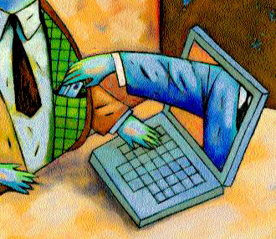
Flaming (Internet)
"is a hostile and insulting interaction between Internet users...
In some cases, flamers wish to upset and offend other members of the forum, in which case they can be called "trolls".
(Wikipedia)

An Internet troll, or simply troll in Internet slang, "is someone who posts controversial, inflammatory, irrelevant or off-topic messages in an online community, such as an online discussion forum or chat room, with the primary intent of provoking other users into an emotional response or to generally disrupt normal on-topic discussion."
(Wikipedia)
WEB QUEST SHEET
Your Name:
1. Who started the Internet?
http://www.walthowe.com/navnet/history.html

Answer:

2. Explain the original purpose and development of the Internet
Answer:

3. Identify three types of users of the Internet
Answer:

4. Identify and define features of the Internet
Answer:

5. Explain the services provided by the Internet their advantages and disadvantages
Answer:

6. Identify different types of networks. LAN, WAN, Internet.
Answer:

7. Who would use a client-server network?
http://compnetworking.about.com/cs/basicnetworking/f/whatsnetworking.htm
Answer:

8. Who would use peer-to-peer networks?
http://compnetworking.about.com/od/basicnetworkingfaqs/a/peer-to-peer.htm
Answer:

9. Access the Internet and Locate the following Information on the Internet
Plot Summary for “Enemy of the State”
Answer:

10. Use a variety of search methods to locate specified information on the Internet

Images from the film “Enemy of the State” including two shots from the movie
(3 images to find)
Answers:

11. List 3 Advantages for using the Internet at a college?
Answer:

Answer:

Answer:

12. List 3 Disadvantages of downloading items from the internet?
Answer:

Answer:

Answer:

13. What is Phishing and Pharming
Answer:

http://www.crime-research.org/news/09.11.2005/1614/

14. What is Digital Convergence
Answer:

http://www.globrocks.com/globrockssitearticles/digitalconvergence.html

15. Network topology Show three types of network topology
(Images will suffice)
http://en.wikipedia.org/wiki/Computer_network#Connection_method

Answer:

Answer:

Answer:

16. Convert the following decimal numbers to their binary equivalent.
http://computer.howstuffworks.com/bytes.htm

25, 10, 181, 327

Hint
You will need to set up a table similar to the one below to help you in answering the questions. This may need to be expanded.

64 | 32 | 16 | 8 | 4 | 2 | 1

17. What are the rules for preventing Cyber Bulling or Predator Danger on the Internet?
http://workingmothers.suite101.com/article.cfm/cyberbullying_and_online_predators
http://www.cybersmart.gov.au/

END OF WEB QUEST

